EXPERIMENT 6
Name: Harshavarthini A Roll No: 240701181
Simulate the life cycle stages for UI Design using the RAD model and develop a small interactive interface Axure.RP, Openproj
RAD MODEL Work Flow Diagram:
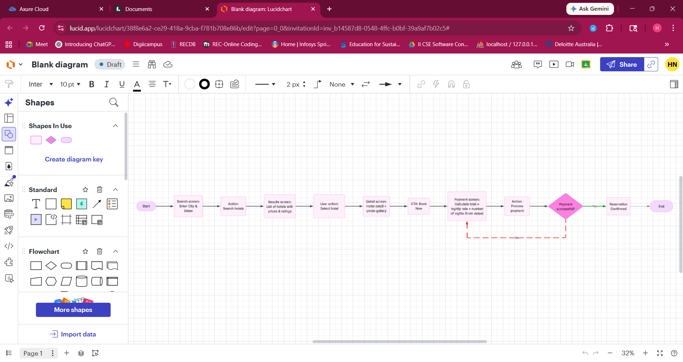
PROCEDURE:
Phase 1: Requirements Planning
- Identify Key Features:
  - Search Interface: Inputs for Destination, Check-in/Check-out dates, and Guest count.
  - Results Dashboard: List of available hotels (e.g., Ocean View Resort, Grand Plaza Hotel) with nightly rates and star ratings.
  - Available Hotel Details: Comprehensive hotel overview, interactive photo gallery, and an amenities list.
  - Checkout & Payment: Form for payment details and an automated order summary.
  - Confirmation: A success screen providing a booking reference and receipt view.
- Requirements Document: Documented user flow (using diagram mentioned above) from initial search to final reservation confirmation.
Phase 2: User Design
- Axure RP Setup: Launched Axure RP and created a new project titled "UID Experiment 6".
- Create Wireframes:
  - Layout: Developed a mobile-responsive interface utilizing the Axure widget library.
  - Visual Elements: Integrated high-quality imagery for the "Home Stay" and "Ocean View Resort" pages to enhance visual fidelity.
- Add Annotations: Used labels and text components to define the purpose of search fields and "Book Now" buttons.
Phase 3: Construction
- Develop Interactive Prototypes:
- Test and Iterate
Phase 4: Cutover
- Finalize and Export: Finalized all interactions and transition styles
- Deployment: Shared the functional prototype via Axure Cloud for review.

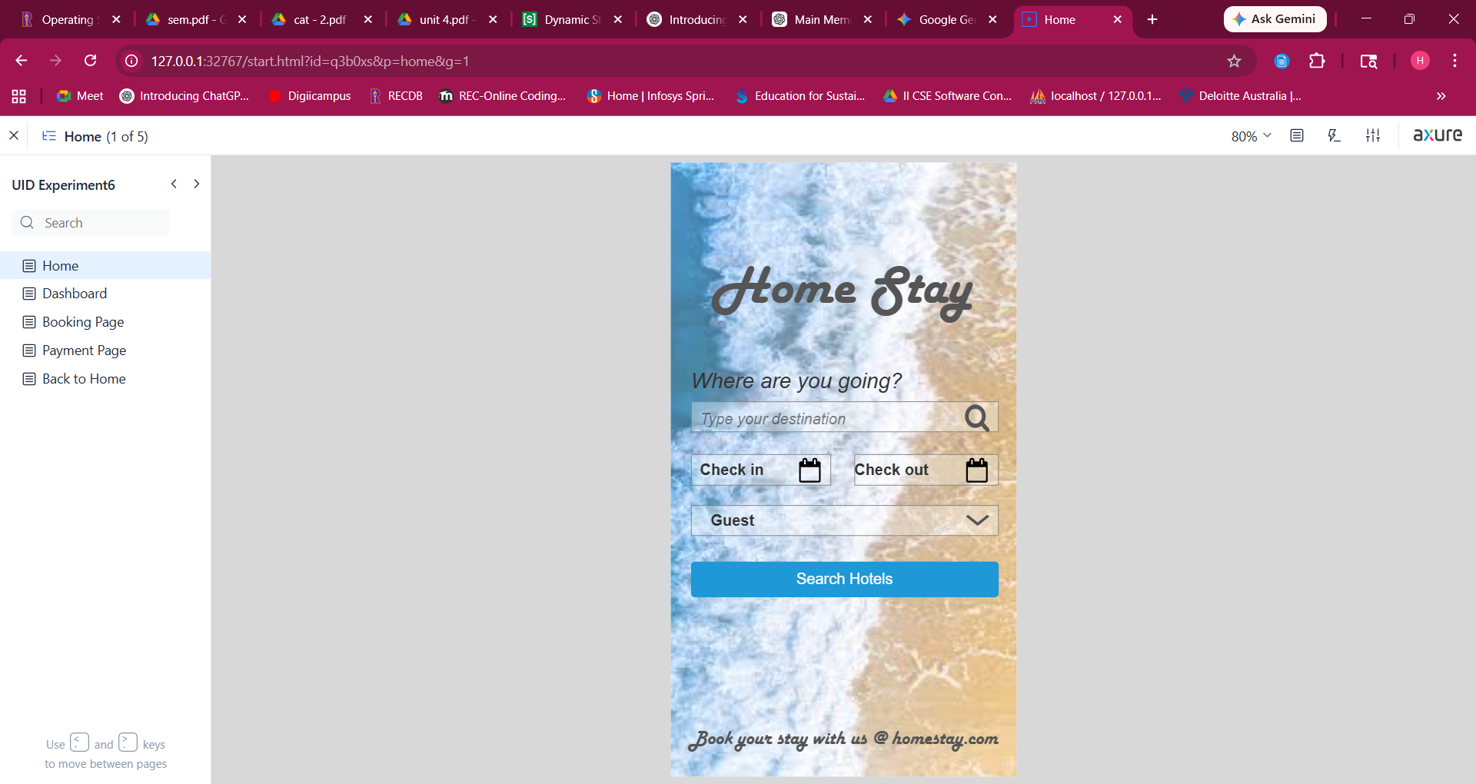http://127.0.0.1:32767/start.html?id=q3b0xs&p=home&g=1
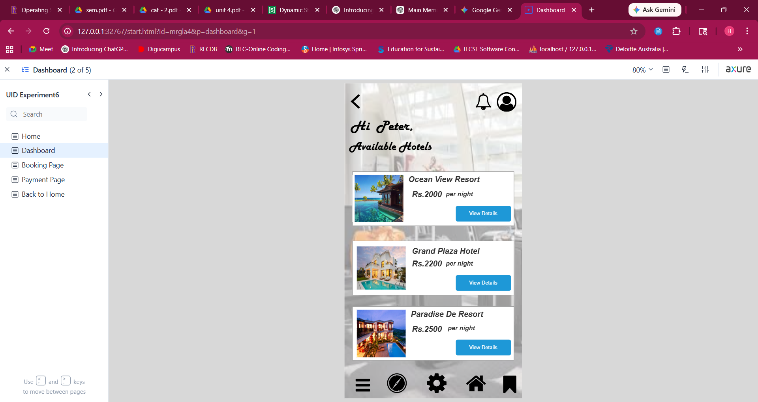http://127.0.0.1:32767/start.html?id=mrgla4&p=dashboard&g=1
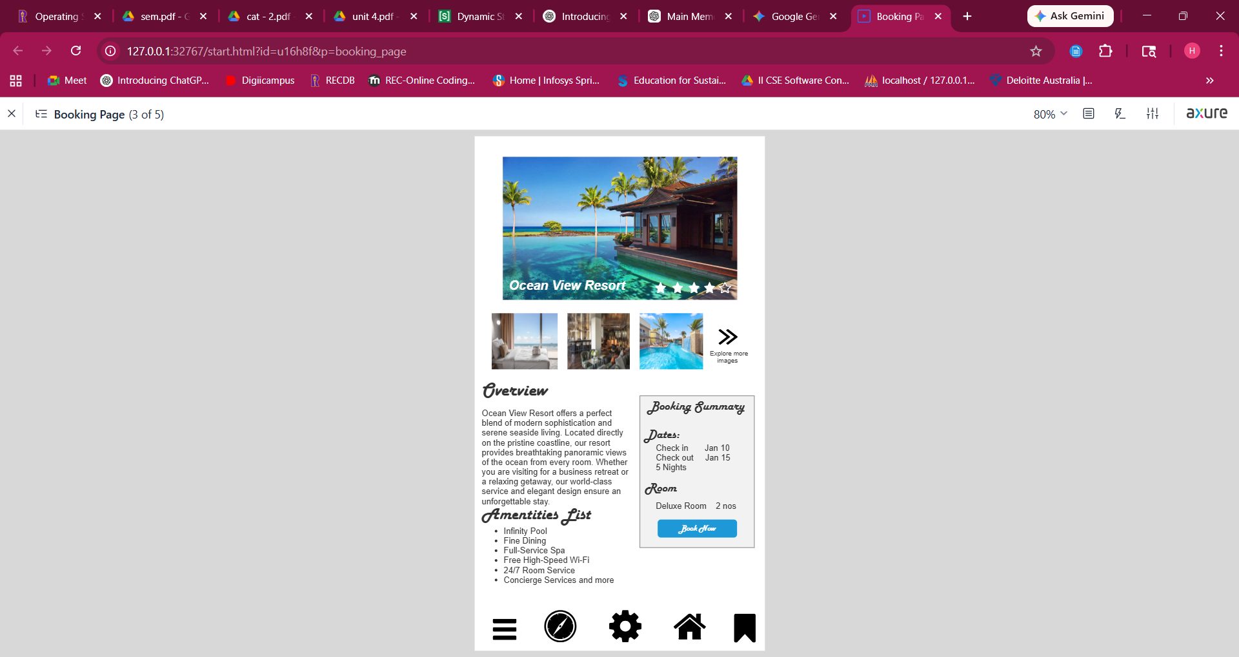http://127.0.0.1:32767/start.html?id=u16h8f&p=booking_page&g=1
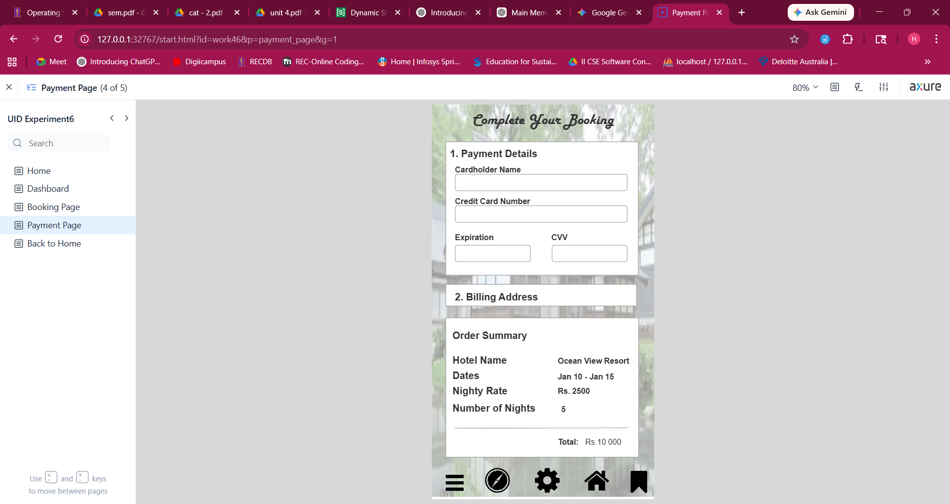http://127.0.0.1:32767/start.html?id=work46&p=payment_page&g=1
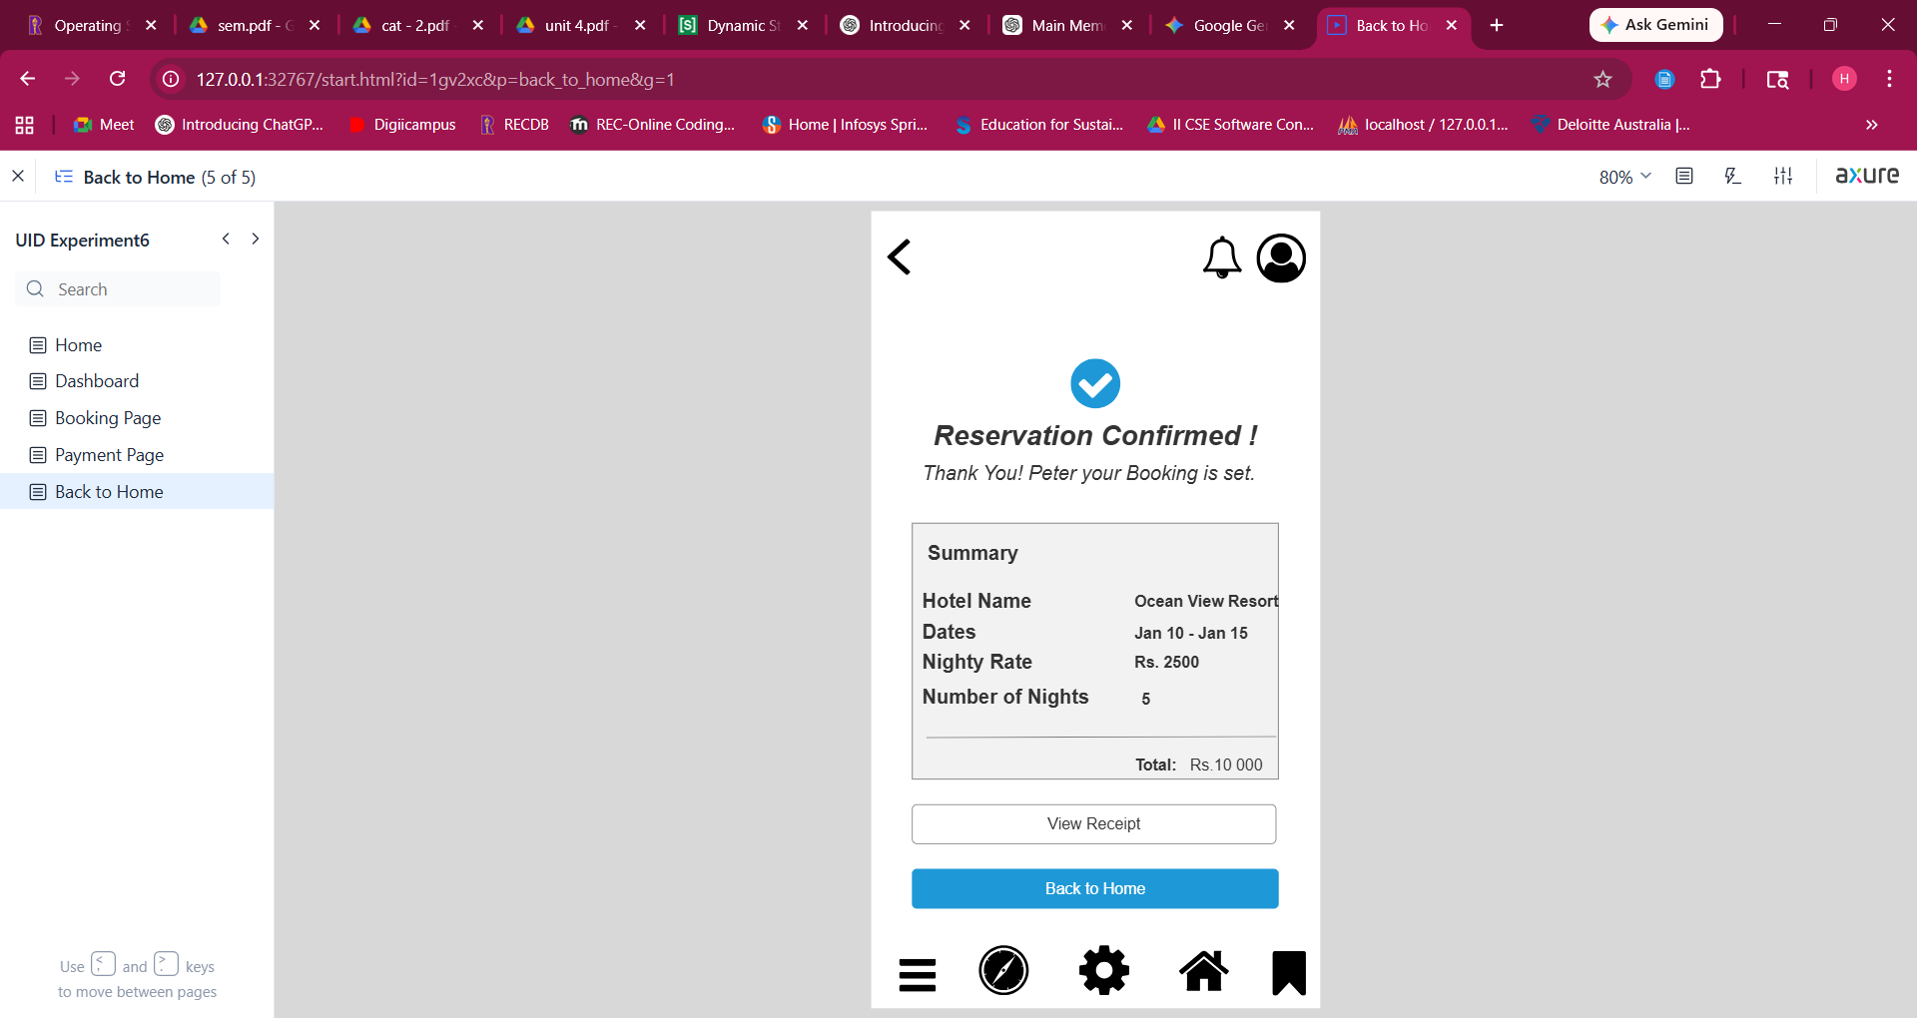http://127.0.0.1:32767/start.html?id=1gv2xc&p=back_to_home&g=1

